Using Video

We are beginning to use video more and more for our social media and e-marketing. The communications department has a new Ipad Pro to film with and edit on.

If you have a smart phone, you too can help add to our video library and help put more eyeballs on the charity and our events.

Why?

Social video generates 1,200% more shares than text and images combined (ref charityDYNAMICS). We are already seeing an increase in reach and engagement with all of our posts that include video.

Where?

If you are at an event, please have a think about taking some video. Hopefully you’ll already be used to taking photos (these can also be used in our film – see below); now though, it would be really useful to switch the camera mode to ‘VIDEO’ as well and capture some footage.

How?

Here are some brief tips to get the most out of your footage…

Keep it short…

The average watch time for videos on social media is 3 seconds.
People just don’t have the time or the patience to sit through a long video clip when they’re on the go and quickly checking Facebook.

Film it landscape…

Please turn your phone on its side so that the video will fill the full screen when it’s viewed on computers/laptops/smartphones.

To help remember, I was always told to think about how the TV’s positioned at home…

Have a think about compostion…

Unless you’re wanting someone to speak directly to the audience (e.g. “Please donate now and help save tiny lives”) DON’T film them in the middle of the shot while looking directly into the camera/phone. It just looks a bit odd.

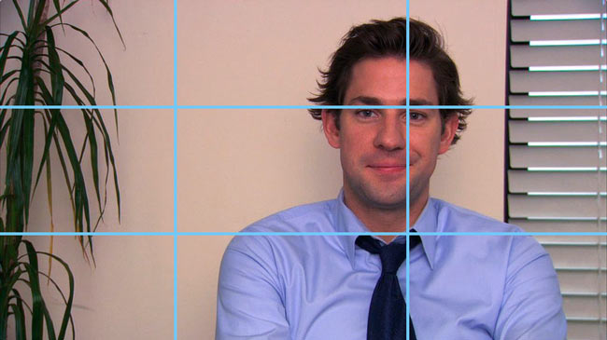
Next time you watch the news, have a look at any interview they conduct either in the studio or out and about. The subject is almost always positioned to one side of the shot and looking at the interviewer.

The technical term is the ‘Theory of Thirds’, where you mentally divide the screen into a grid.

Also think about avoiding anything
Theory of Thirds: See how the subject is framed just right of centre and his gaze cuts across the empty space on the left of our screens towards the interviewer.
distracting in the background.

Watch the light…

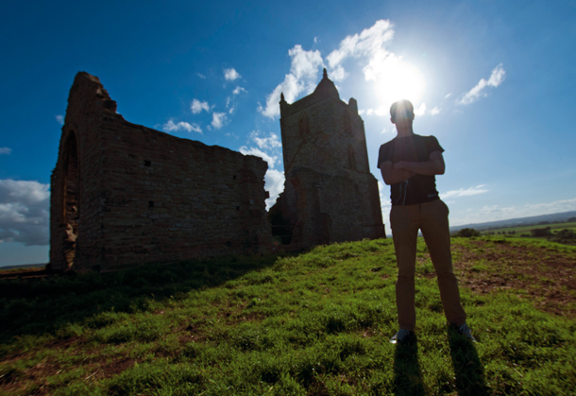
Whether you’re filming indoors or out, keep your eye on where your main source of light is. Ideally it wants to be behind you, otherwise your subject will be very dark.

In this example, the sun is right behind the subject and so both he and the ruins are cast in shadow.

Even turning the camera 90 degrees either way (away from the sun) would have helped.

Soundcheck…

Finally, just be aware of background noise.

If you’re at a busy event, a bit of noise could help capture the atmosphere.

If you’re trying to capture someone talking, just make sure the radio/air-conditioning/hair-dryer isn’t on in the background.

Photos

We can still use photographs to help produce film; montages of still images are very easy to make and can be just as effective. So don’t stop taking pics!

What to do when you have your video/photos

Email film@action.org.uk – please always cc pdenton@action.org.uk

Queries

Any queries, please contact Peter pdenton@action.org.uk or Kate klee@action.org.uk in Communications.

