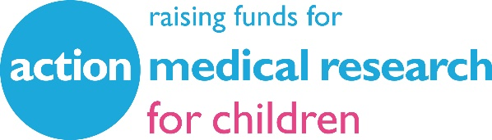

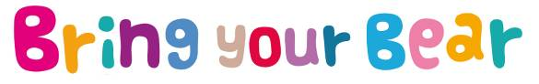

The children from
[INSERT SCHOOL/NURSERY NAME AND LOCATION]
will be joining schools, nurseries and children’s groups across the UK to celebrate their favourite bears this year by holding a Bring your Bear day.

The aim of Bring your Bear is to raise funds for Paddington’s favourite UK charity, Action Medical Research. Our special event will take place on

[DATE]

Bring your Bear is a fun and educational event that raises vital funds for the charity to help sick babies and children. Everyone pays a pound or two to bring their teddy bear, or closest cuddly companion, to school or nursery with them for the day.

The children and their bears then take part in fun activities. Here are just some of the things that will be happening at our Bring your Bear day:

Megan McFarlane at Action Medical Research says: “Bring your Bear is a really fun event for children and a great way for them to show they care. It’s lovely to see them getting involved and every year we receive fantastic feedback about what they’ve been doing. We hope children all over the UK will join in and help us to fund even more life-changing research for some of the UK’s sickest babies and children.”

You can find out more about Bring your Bear at www.action.org.uk/byb

For more information on Action Medical Research contact:
Grace Wardley, Communications and Engagement Officer:
T: 07725 090008 or out of hours PR phone: 07754 320281
E: gwardley@action.org.uk
W: www.action.org.uk

Follow us on Twitter at @actionmedres and @amr_events
Like our Facebook page at @actionmedres and @actionevents
Follow us on Instagram at @actionmedres and @actionevents

Action Medical Research is the leading UK-wide charity dedicated to saving and changing children’s lives through medical research. For over 70 years we’ve helped pioneer ways to prevent disease and develop treatments benefiting millions of people. Our research has helped to beat polio in the UK, develop ultrasound in pregnancy, fight meningitis and prevent stillbirths. But we urgently need to develop more new treatments and cures for sick babies and children and we can’t do it without you.
Join our fight for little lives today.
Charity reg. nos 208701 and SC039284.

